Conditional Generation: Intuition
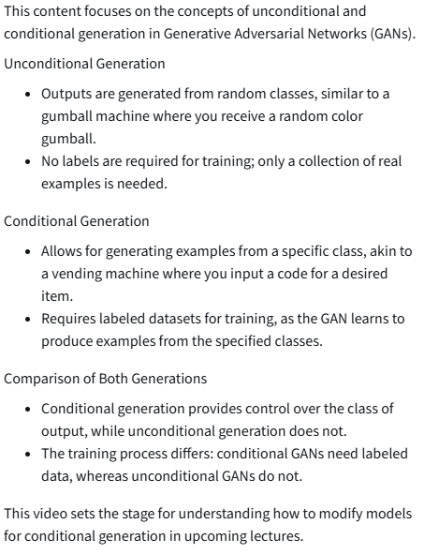

Conditional Generation: Inputs
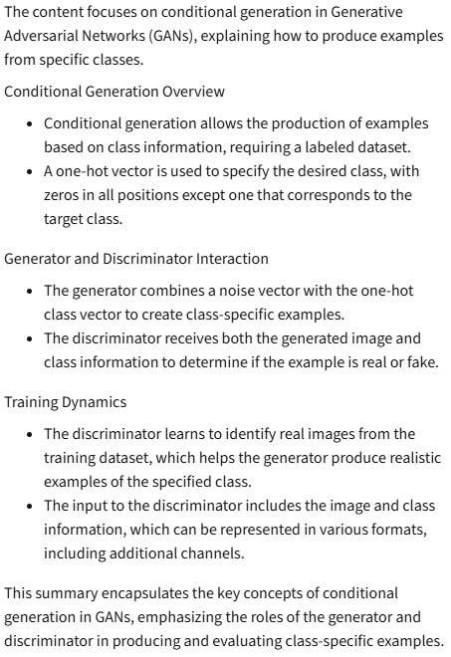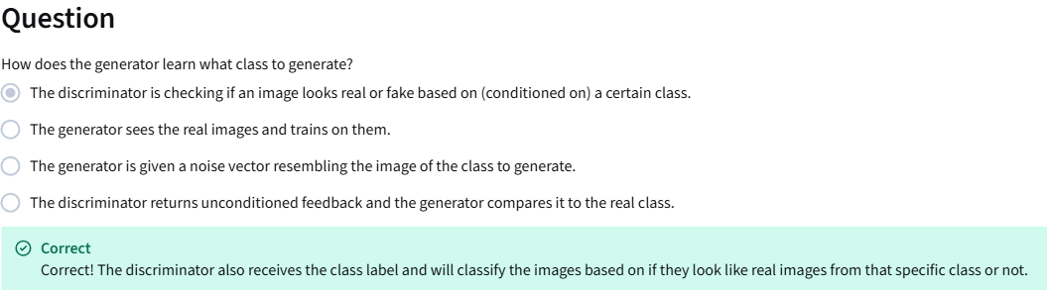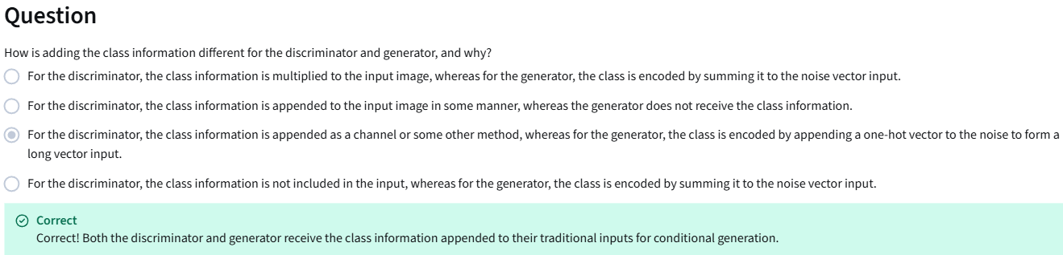
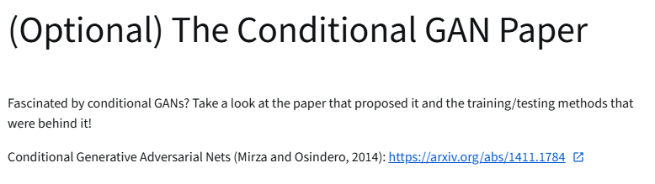
https://arxiv.org/abs/1411.1784

Controllable Generation
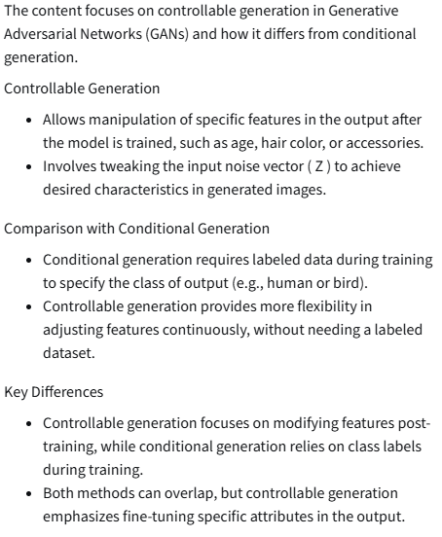

Vector Algebra in the Z-Space
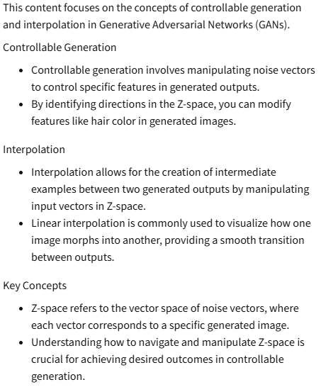
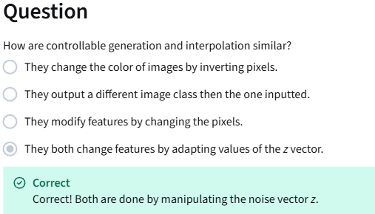

Challenges with Controllable Generation
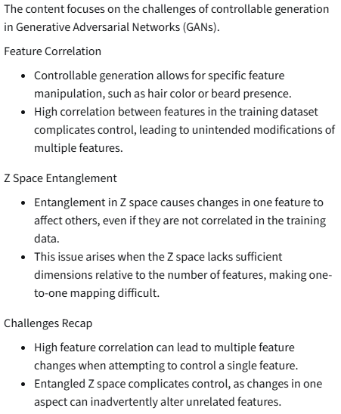
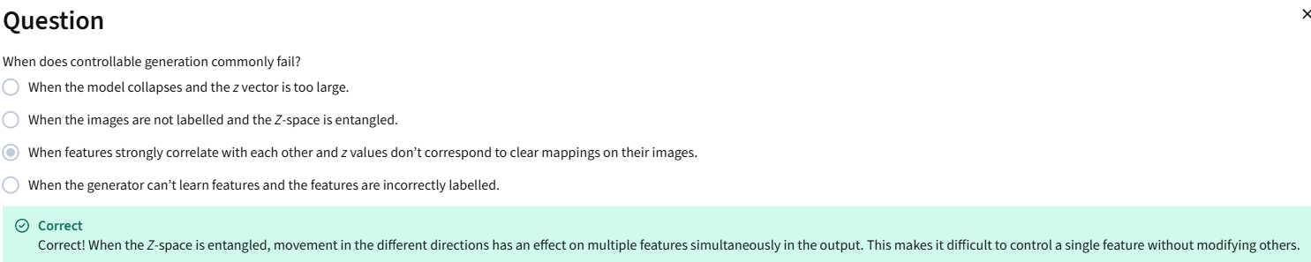

Classifier Gradients
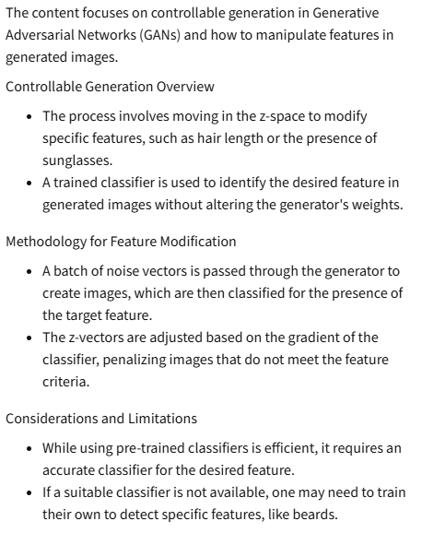
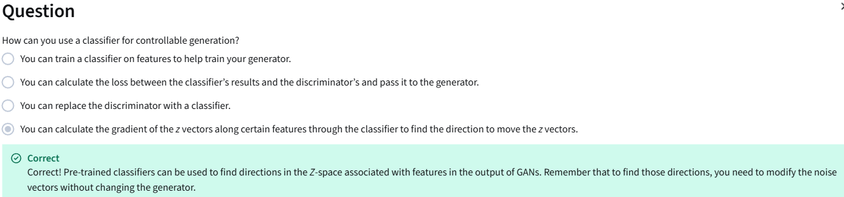

Disentanglement
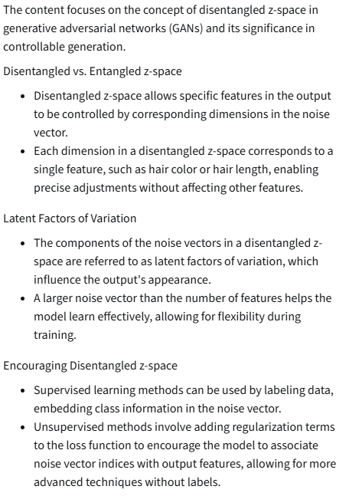
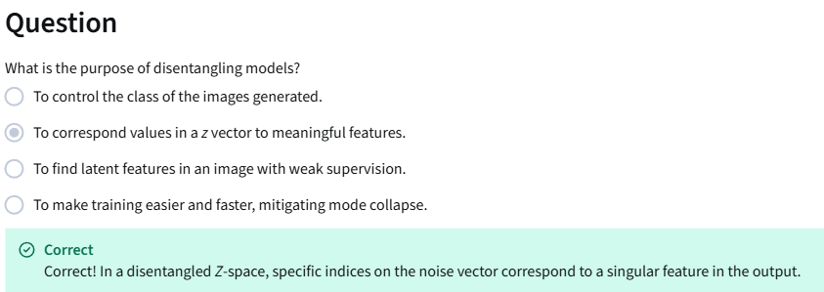
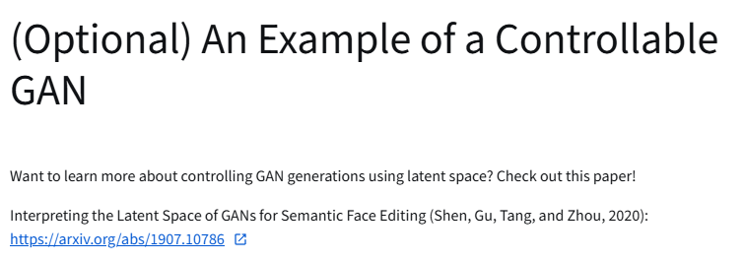
https://arxiv.org/abs/1907.10786

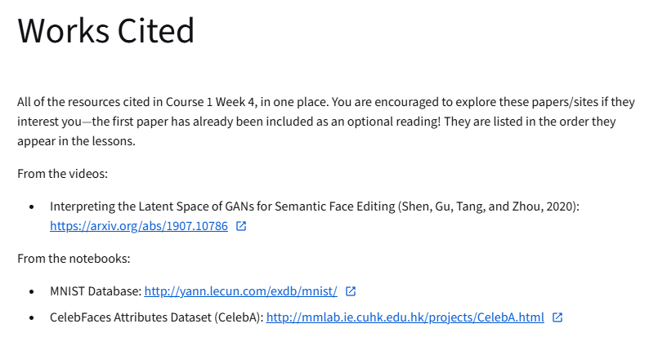
https://arxiv.org/abs/1907.10786
http://yann.lecun.com/exdb/mnist/
https://mmlab.ie.cuhk.edu.hk/projects/CelebA.html

